Create Lambda function using python and boto3

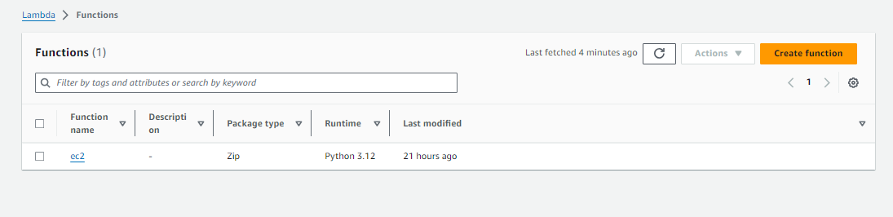  
(this func to stop ec2)

* 1. The function should get list of EC2 instances

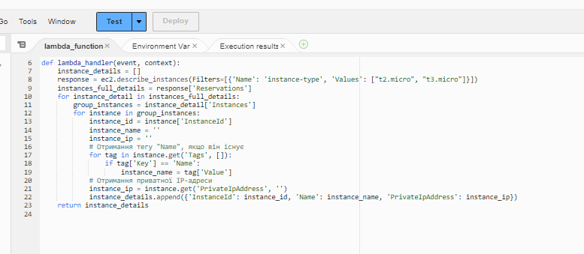

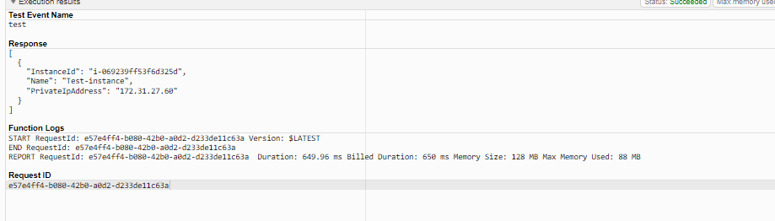

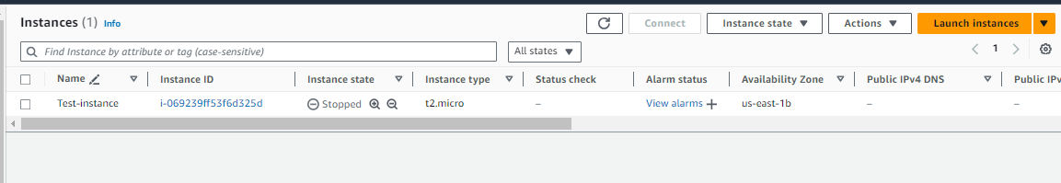

1.2. Check if it is running and has the "Owner=Your Name" tag

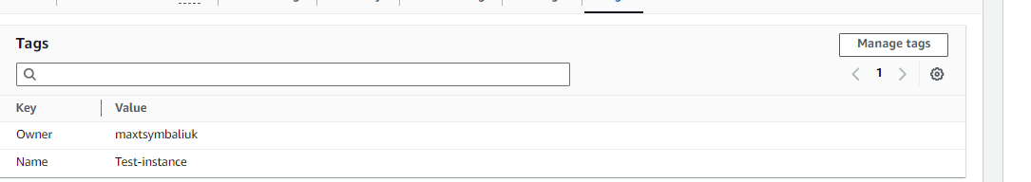

1.3. Then stop it or skip otherwise

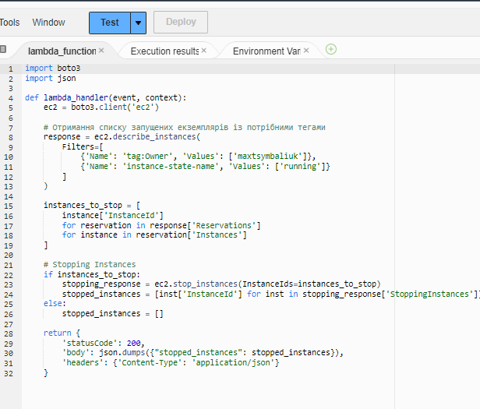

1.4. Return the list of stopped instance IDs

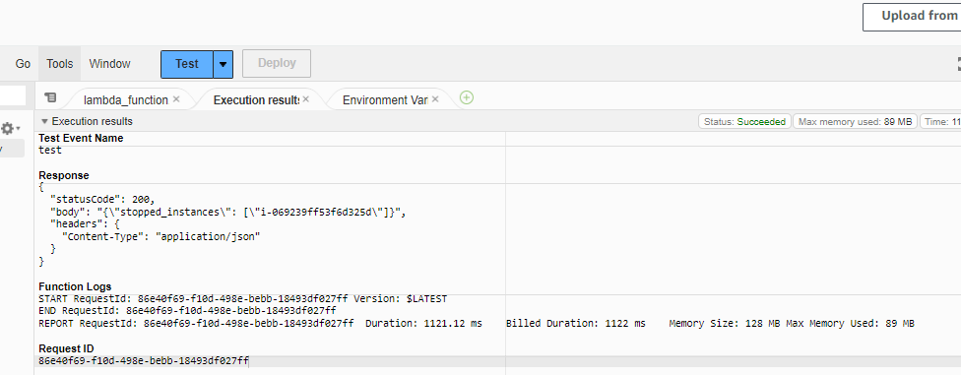

1. Create Lambda function using python and boto3

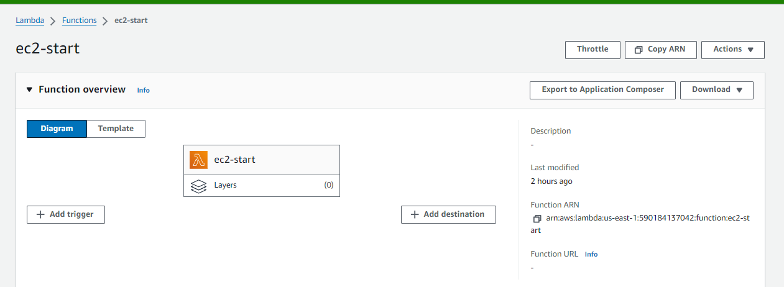

* 1. The function should get list of EC2 instances



* 1. Check if it is stopped and has the "Owner=Your Name" tag



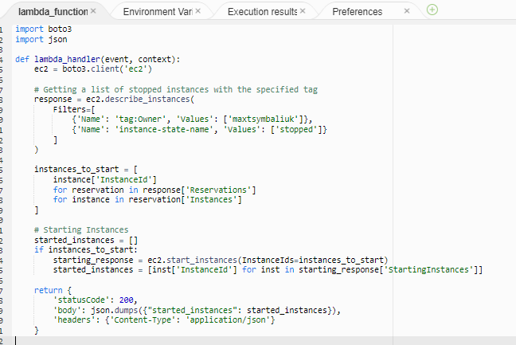

2.3. Then start it or skip otherwise 2.4. Return the list of started instance IDs

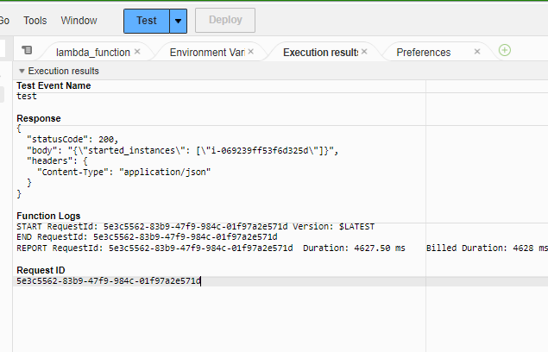

1. Run both lambda functions and confirm that they work





**API GW**

1. Create API gateway with the following endpoints:

* /instances/stop - triggers the 1st lambda
* /instances/start - triggers the 2nd lambda

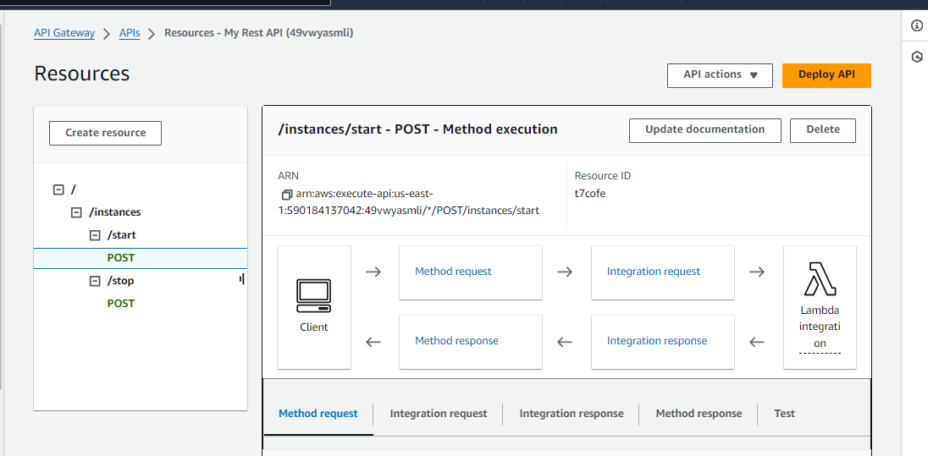

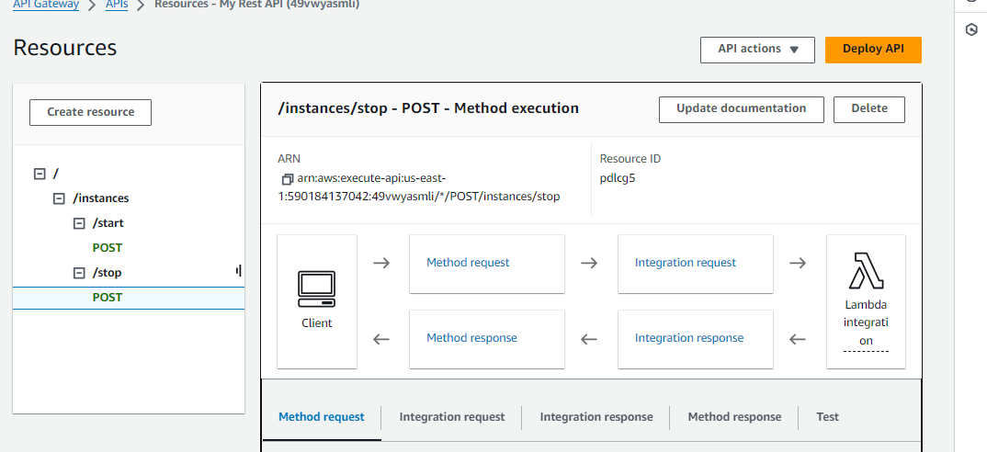

1. Confirm that it works as expected

